📄 Test Case: TC59_InwardLodgeBill
✅ PASSED:
[2026-03-11 17:01:52] Bill ID - 003B0502_2025 Lodged successfully.
[2026-03-11 17:02:52] Bill ID - 003B0502_2025 verified successfully.

📄 Test Case: TC60_ModifyTheLodgeBillWhichIscreated
✅ PASSED:
[2026-03-11 17:04:13] Bill ID - 003B0502_2025 modified successfully.

📄 Test Case: TC61_CanceltheModifiedInwardBill
❌ FAILED:
[2026-03-11 17:05:15] ?? Error displayed: SYS - Could Not Get Response from Server
[2026-03-11 17:05:15] ? Assertion Failure: ? Unexpected error during Mark/Invoke: SYS - Could Not Get Response from Server
↳ Reason: ❌ ❌ Assertion Failure: ❌ Unexpected error during Mark/Invoke: SYS - Could Not Get Response from Server

📄 Test Case: TC62_AmendTheInwardBillWhichIsLodge
❌ FAILED:
[2026-03-11 17:06:22] errorMsg = E4221 - Record is Modified & Verification is pending
[2026-03-11 17:06:22] LabelText: null
[2026-03-11 17:06:22] BillID: null
[2026-03-11 17:06:22] ? Error: E4221 - Record is Modified & Verification is pending
[2026-03-11 17:06:22] ? Assertion Failure: Test failed: E4221 - Record is Modified & Verification is pending
↳ Reason: ❌ ❌ Assertion Failure: Test failed: E4221 - Record is Modified & Verification is pending

📸 Screenshot:
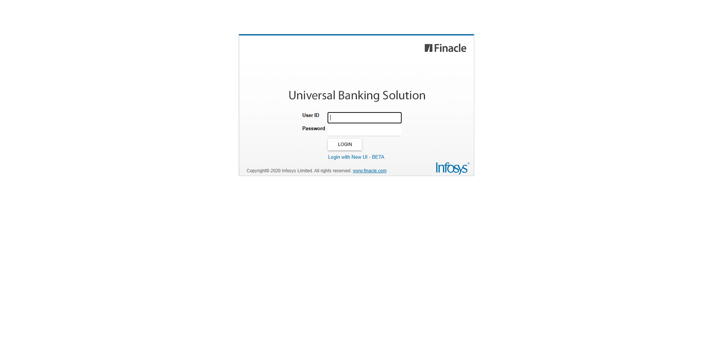
📄 Test Case: TC63_DishonorOfInwardBillWhichIsAmended
❌ FAILED:
[2026-03-11 17:07:25] ? Error: E4221 - The bill ID cannot be dishonored. Bill Status: [Protested]
[2026-03-11 17:07:25] ? Assertion Failure: Test failed: E4221 - The bill ID cannot be dishonored. Bill Status: [Protested]
↳ Reason: ❌ ❌ Assertion Failure: Test failed: E4221 - The bill ID cannot be dishonored. Bill Status: [Protested]

📸 Screenshot:

📄 Test Case: TC64_InquireTheInwardBill
✅ PASSED:
[2026-03-11 17:08:00] ? Inward Bill No: 003B0502_2025
[2026-03-11 17:08:00] ? Inquired Successfully – Import No: 003B0502_2025
[2026-03-11 17:08:00] ? AppData captured at inquiry time:
[2026-03-11 17:08:00] acceptDate_ui = 15-03-2025
[2026-03-11 17:08:00] billType = IMDCBU
[2026-03-11 17:08:00] shpmntDate_ui = 15-03-2025
[2026-03-11 17:08:00] invoiceAmt = 1000.00
[2026-03-11 17:08:00] docStatus = Clean
[2026-03-11 17:08:00] LABELTEXT_BILLID = 003B0502_2025
[2026-03-11 17:08:00] boeAmt = 1000.00
[2026-03-11 17:08:00] billCountry = 03
[2026-03-11 17:08:00] billId = 003B0502_2025
[2026-03-11 17:08:00] billDate_ui = 15-03-2025
[2026-03-11 17:08:00] carrierCode = 001
[2026-03-11 17:08:00] LabelText = Inquired Successfully – Import No: 003B0502_2025
[2026-03-11 17:08:00] otherBankRefNo = 124

📄 Test Case: TC65_ProtestTheInwardBillWhichIsDishonoured
❌ FAILED:
[2026-03-11 17:08:52] ? Error: D89 - Bill has already been protested.
[2026-03-11 17:08:52] ? Assertion Failure: Test failed: D89 - Bill has already been protested.
↳ Reason: ❌ ❌ Assertion Failure: Test failed: D89 - Bill has already been protested.

📸 Screenshot:
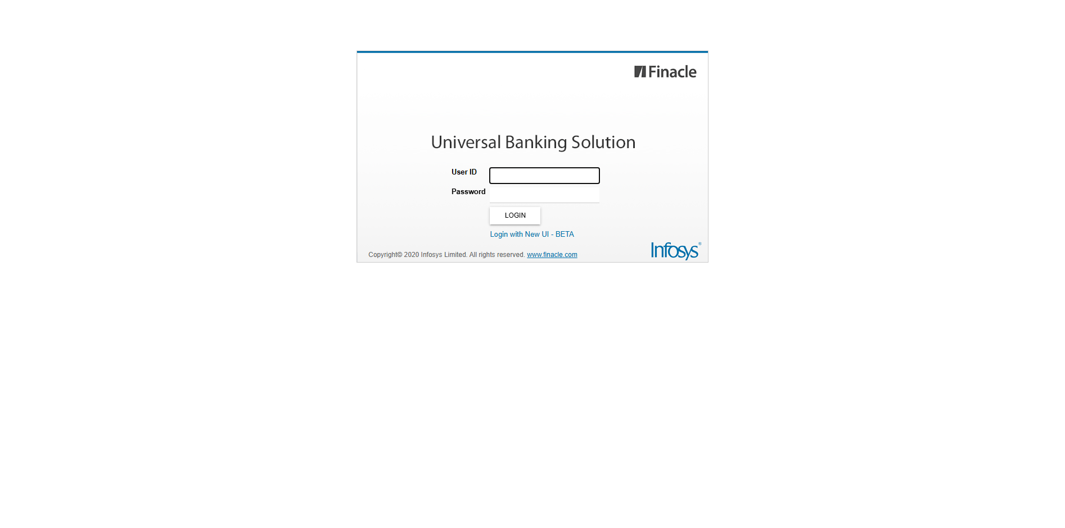
============================================================
📊 Suite Summary: MIIBTests
===============================================
MIIBTests
Total tests run: 7, Passes: 3, Failures: 4, Skips: 0
===============================================
⏱️ Total Duration: 07 min 54 sec

